Essential Kind Membership and Possible Worlds or Could Aristotle Have Been A Paper Clip?

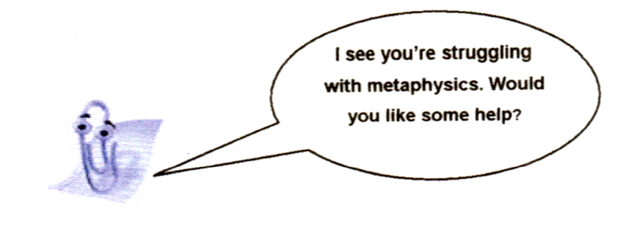
- Essential Kind Membership
At stake are the identity & persistence conditions of an individual through changes in Its properties.

Definition: individual = object, entity, particular - these are all ways of referring to things that can be counted.
Examples below are all particular instances of distinct categories or kinds.

1) a human being
2) a giraffe
3) a caterpillar
4) a parsnip
5) a lump of gold
6) a block of ice
7) a paperclip
8) a snowstorm
9) the number 17
10) the chemical compound water

What is at issue: whether it is possible for an individual in one of the categories above to metamorphose into an
individual from one of the other categories, or to have spent its entire existence as a member of a distinct category.

Side A support Essential Kind Membership:
- Nothing can change from being an F to being a not-F and still continue to exist,
ii. Nothing that is actually an F can have spent its entire existence as a not-F.

On side A: Aristotle, David Wiggins, Saul Kripke, Kit Fine.

Side B rejects EKM because we are not rationally required to accept it. Moreover, they have different intuition as to
how the world works.

On side B: David Hume, David Lewis, Penelope Mackie.

2) What are ‘Possible Worlds’?

a) Clarification
‘Possible worlds’ in philosophy are a logical tool. They reflect our intuitions regarding modality, i.e. what is necessary, possible or impossible. They are a neat and simple way of assigning truth values to conditional and counterfactual statements.
b) Counterfactuals: how things might have been
‘If I’d left home 5 minutes earlier, I’d have caught the 4.57 train’ can be expressed by saying that there is a possible world where I left home 5 minutes earlier and did catch the train. The statement: ‘pigs might fly’ is expressed by saying that there’s a possible world where pigs do fly.

c) Modal definitions
i) Necessity, possibility and impossibility are interdefinable - think about it. And of course, anything which is actual
must be possible.
ii) A statement is necessarily true if if s true in all possible worlds. Example: ‘2+2 = 4’.
iii) A statement is possibly true if if s true in at least one possible world. Example: ‘My car is grey’.
iv) A statement is impossible if it’s true in no possible world. Example: This shirt is both blue and not blue’ or
‘electrons have positive charge’.
v) ‘Essential’ and ‘necessary’ for the purposes of Possible Worlds come down to the same thing. I’ll say more about that later, if time.

3) Against EKM: The neo-Humean or David Lewis view of Possible Worlds

All possible worlds are real, but only one world is actualized – that’s the one we’re in. Our job is to work out which world that is by excluding all the unactualised worlds. Impossibility and possibility are cashed out in terms of remoteness and proximity of the unactualised worlds.

Remote worlds would be those with philosophers turning into paperclips. Nearby worlds are those where this event
takes place in the Lecture Theatre.
Individual objects like Aristotle are simply ‘bundles’ of properties. In each possible world the bundle which is
Aristotle becomes a different bundle - a ‘counterpart’ of the actual world Aristotle, not identical with him.

4) In favour of EKM: The neo-Aristotelian view

a) Saul Kripke, b.1941 (Naming and Necessity 1980)
Possible worlds are states our actual world - our universe - might be in or might have been in. We take our actual world Aristotle, that very man, evaluating what might have happened to him, had circumstances of our actual world been different. But in no circumstances of our actual world would he have been a paperclip.

b) David Wiggins, b. 1933 (Sameness & Substance Renewed 2001)
The kind to which an individual belongs determines its identity - it determines what it is. And what it is determines its persistence conditions - the changes it can undergo. The persistence conditions of an individual are kind-specific and stem from empirically-discovered essential properties. Examples: having a particular chemical constitution, a particular atomic number, a particular biological origin and genomic profile etc, etc.

Recall that Side A is trying to defend EKM

- Nothing can change from being an F to being a not-F and still continue to exist.
- Nothing that is actually an F can have spent its entire existence as a not-F.

Wiggins has the Aristotelian notion of a substantial kind. It lends support to the first plank of EKM.

Definition: A kind k is a Substantial Kind iff it is such that an object x that belongs to k at any time in its existence belongs to k at all times in its existence.

Consequence: an individual x comes into existence as a member of a particular kind, with the set of persistence conditions distinctive of that kind, and goes out of existence as a member of that same kind.

5) Penelope Mackie against EKM

There is a logical gap between the two planks of the EKM claim. The first does not entail the second. So, even if Aristotle can’t change from a human being into a centipede, puddle of water or the number 17, it does not logically follow that he could not have spent his entire existence as one of these things instead.

What we need to support plank ii) is an Essential Kind claim, which substitutes worlds for times

Definition: a kind k is an Essential Kind iff it is such that if an object x belongs to k in any possible world - which will of course include the actual world - then x belongs to k in all possible worlds where x exists.

How to argue for it? Mackie suggests the following:

‘If there is any kind of thing such that, necessarily, everything that belongs to that kind belongs to it essentially, then if Aristotle does not in fact belong to that kind, he could not have done so.’ (2006:165) For example, if it is the case that every number is essentially a number, then if Aristotle is a number in any world, he must be a number in all possible worlds, including the actual world. Since he is clearly not a number in the actual world, he could not have been a number in any world.

So there might be general Essential Kinds from which Aristotle is necessarily excluded - material object, abstract object, event, number - that we can rationally accept, even if we reject essentialism. So if Aristotle is not a football match, a mathematical theorem or the number 17 in the actual world, then he could not have been any of these things. But... if material object is an Essential Kind, we can’t exclude Aristotle because he too is a material object - in which case he could still have been a paperclip!
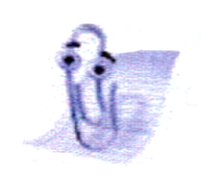So I’ve proved I can be a paperclip. Now, how do I get back to being Aristotle?

